

Logic Design LaboratoryExperiments

Exp 1: Introduction to Digital Logic Kit KL-31001



December 1, 2022

Ninevah university

College of information Technology – CNI Department



**Introduction to KL-31001 DIGITAL LOGIC LAB**

**Objective:** Understanding the Input/output units for KL-31001 Kit.

**Introduction:**

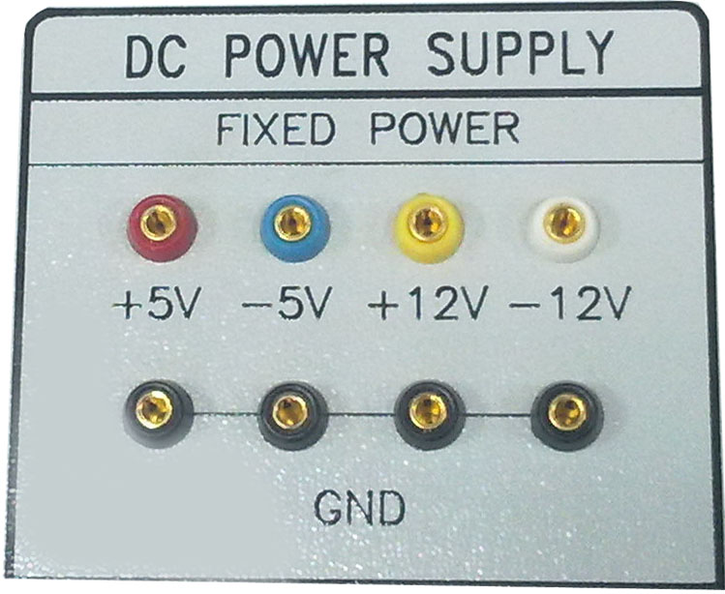**1. Power Supply.**

**2. Switches (Input).**

4-Input TTL Switches (5 volt provide) Or

4-Input CMOS Switches(12 volt provide)

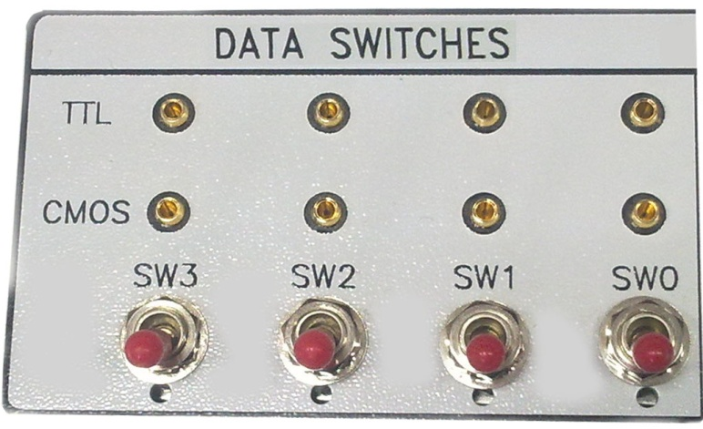

**3. Dip Switches (Input).**

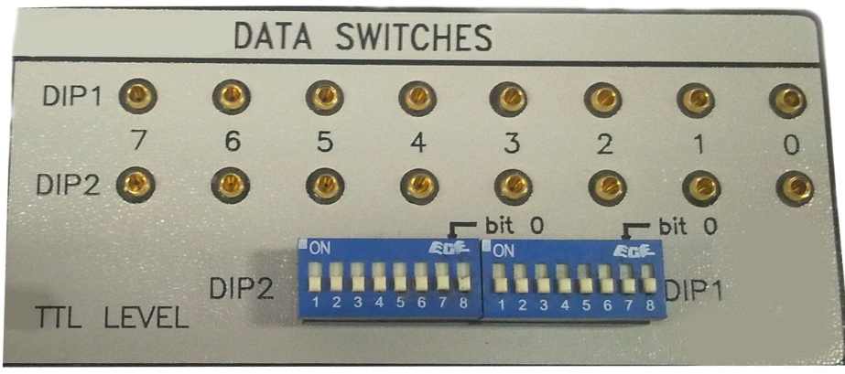

**4. Thumbwheel Switches (Input).**

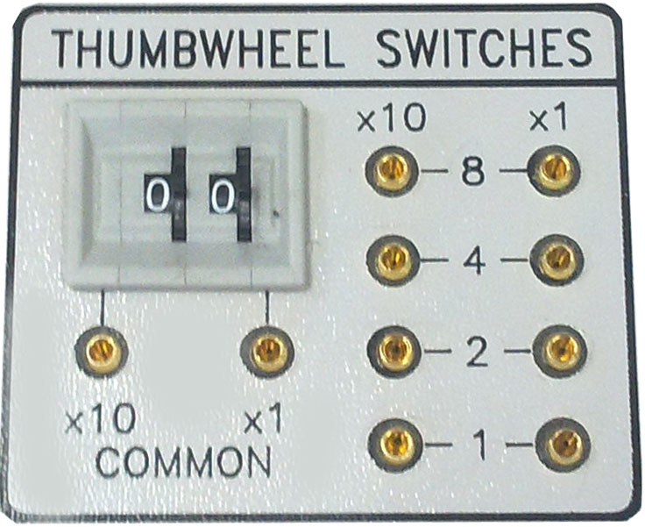

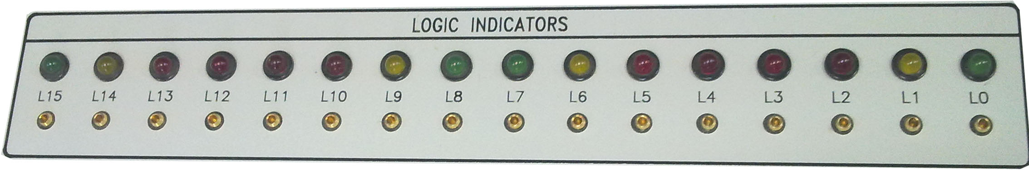**5. Light Emitting Diodes LEDS (Output).**

**6. Digital Displays (7-Seqment Display) Output.**

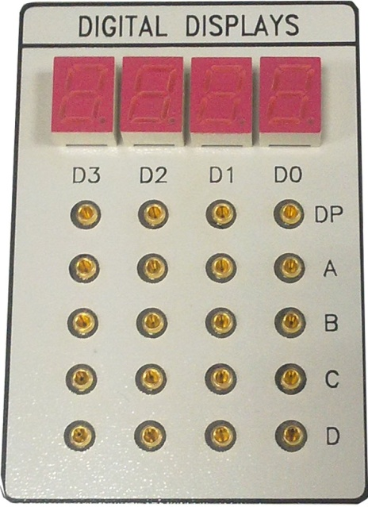

**Procedure:**

1. Connect the TTL input switches (SW0, SW1, SW2 and SW3) to LEDS (L0, L1, L2 and L3), change the input from (0000 to 1111) and show the outputs on the LEDS.
2. Connect the DIP1 input switches (0 to 7) to the output LEDS (L0 to L7), display the following values in binary (**9**,**15**, **33**,**69**,**106**,**155**,**203**,**250**).

* What is the difference between steps 1 and 2?

1. Connect the thumbwheel switches x1 and x10 to the power supply (+5V), take the output of x1 to the 7-segment D0 and (L0,L1,L2 and L3), and x10 to 7-segment D1 and (L4,L5,L6 and L7) , change the input form (**00** to **25**) and show the results on 7-segments and LEDS at the same time.

* What is the difference between the results on 7-segments and on the LEDS?